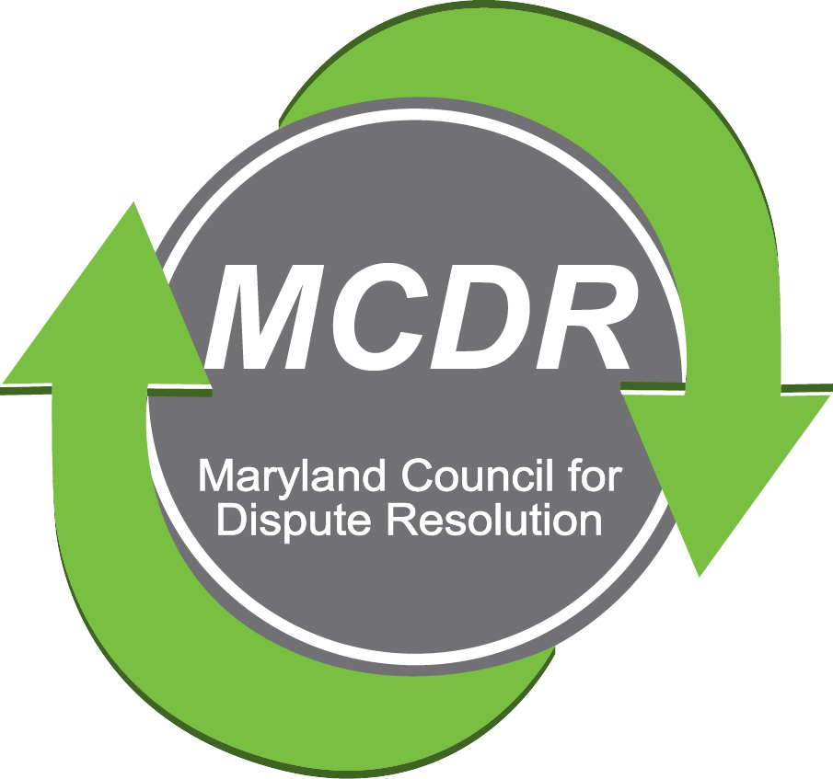

MARYLAND COUNCIL FOR DISPUTE RESOLUTION
APPLICATION FORM
For 2018-2019
MEDIATOR ASSESSMENT/CERTIFICATION

Name______________________________________________________________

Address_____________________________________________________________

____________________________________________________________________

Home Telephone___________________________________

Cell Telephone____________________________________

Mediation Training

A. Basic Mediation Training (40 hours)

Name of Training______________________________________________________

Name of Trainer/Trainers________________________________________________

Number of Classroom Hours___________

Location of Training and Dates___________________________________________
Please Note: Please attach a certificate or letter of completion and a copy of the agenda for the training. If this has been lost, please attach whatever documentation you have. Attachments for Basic Mediation Training are as follows: ______________________________________________________________

____________________________________________________________________
B. Advanced Training: If you have had advanced mediation training beyond the basic 40 hours, or if you have had mediation training in a content area, please fill out the section below. If necessary, please add a separate sheet.

Name of Training______________________________________________________

Name of Trainer/Trainers________________________________________________

Subject Matter (if not obvious from training title) _____________________________
_____________________________________________________________________

Number of Classroom Hours____________________

Location of Training and Dates___________________________________________

Please Note: Please attach a certificate or letter of completion and a copy of the agenda for the advanced training. If this has been lost, please attach any documentation you have.

Attachments for advanced or specialized training are as follows: ________________

_____________________________________________________________________

Education

Degree____ Subject_________ Date_____ Educ.Institution_______________________

Degree_____Subject_________ Date_____ Educ. Institution______________________

Experience/Practice

Practice as a Mediator:
Please indicate how many mediation cases you have mediated (or approximate if exact number not known); of what kinds of cases; and over how much time.

_______________________________________________________________________

________________________________________________________________________

Mediation Style
Please indicate your mediation style (check all that apply): ____ Facilitative,
____ Transformative, ____ Evaluative ___________ (Other – please describe)

* Please remember to attach your Self Statement

Practice in a Non-Mediation Area:

If you have practiced in a specialty area or profession and therefore have a working
knowledge of a content area as listed in the appendix of the MCDR Mediator Qualifications, please complete the statement below:

I hereby certify that as __________________________________, I have practiced in the
(Profession such as therapist, lawyer, accountant, etc.)
area of ____________________________________________ for _______ years and
(Content area)
have handled at least ____________ cases of this type.

References.

Two references are required; references may be from a trainer, a mentor or someone who has co-mediated with you. If such people are no longer available to you, two references from experienced mediators familiar with your work can be used. Please indicate below if such reference letters/forms are attached or are being sent separately:

________ Reference forms attached.

________ References are being sent under separate cover. References are:

a____________________________________

b._____________________________________

Oath and Certification of Compliance with Ethical Standards

I swear or affirm under the penalties of perjury that the information given in this application is true and correct and I certify that I have read the Maryland Standards of Conduct for Mediators and that I agree to abide by them.

________________________________________________________________
Signature date

Please send your completed application and self statement to:

MCDR
c/o Kate Cullen
Chairperson of MCDR Certification Committee
13438 Old Annapolis Road
Mount Airy, MD 21771

Payment for Certification

The fee for Certification is $325 for MCDR members; $395 for MCDR non-members

Payment can be made by check made payable to the Maryland Council for Dispute Resolution and submitted as shown above with your application.

Payment can also be made using your Credit Card by ordering through our website, MCDR.org. On the Home Page, click on the MCDR Store sub-tab to place your order and make payment.

Payment can be made using cash $US paid to the Chair of the MCDR Certification Committee. A cash receipt will be issued.

